Day and night

Why do you think it gets dark at night?

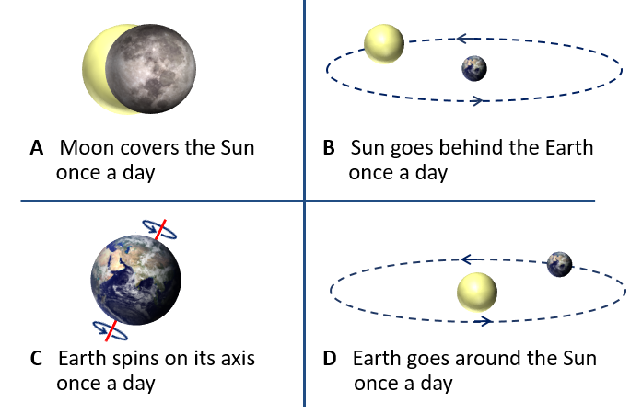

Physics > Big idea PES: Earth in space > Topic PES1: Solar System and beyond > Key concept PES1.1: Planets and the Solar System
Diagnostic question
Day and night

Overview
Learning focus: | In the Solar System: eight planets orbit a star called the Sun; moons orbit most of the planets; and the planets spin on their axes. We live on the Earth where: a year is defined as the time for the Earth to orbit the Sun; a day as the time it takes the Earth to spin on its axis; and the Moon orbits in about 28 days. The planets are very small compared to the huge distances between them.
Observable learning outcome: | - Describe how the Earth spins on its axis and explain what a day is
Question type: | Diagnostic, simple multiple choice
Key words: | Earth, Sun, Moon, axis

P | PRIOR UNDERSTANDING  This diagnostic question probes understanding of ideas that are usually taught at age 5-11, to aid transition from earlier stages of learning.

What does the research say?
It can be tempting to keep work on the Solar System simple and descriptive when in fact it is conceptually demanding (Osborne, 2011). The scientific explanations for simple observations such as the Sun moving across the sky each day are not obvious and sometimes counter intuitive. The Sun’s ‘movement’ across the sky happens not because the Sun is moving, which is the most obvious explanation, but because the Earth is spinning on its axis.
A study of thirty-two Tasmanian students identified a progression in students’ thinking from a model with the Earth at the centre, which was held by about three-quarters of the 9- and 10-year-olds, to a model with the Sun at the centre that is understood by the majority of the 11- and 12-year-olds (Jones, Lynch and Reesink, 1987). To correctly explain observable phenomena that are caused by movement of the Earth, Sun and Moon students need to understand the correct scientific model. If they are using a model that is incorrect students are likely to form further misunderstandings and about a quarter of 11- and 12-year-olds are using incorrect models.
One of the key findings of Lelliott and Rollnick's (2009) review of astronomy education research (1974-2008) was the need for teachers to use physical models both to scaffold learning and to challenge misunderstanding.
Ways to use this question
Students should complete the question individually. This could be a pencil and paper exercise, or you could use an electronic ‘voting system’ or mini white boards and the PowerPoint presentation.
The answers to the question will show you whether students understood the concept sufficiently well to apply it correctly.
If there is a range of answers, you may choose to respond through structured class discussion. Ask one student to explain why they gave the answer they did; ask another student to explain why they agree with them; ask another to explain why they disagree, and so on. This sort of discussion gives students the opportunity to explore their thinking and for you to really understand their learning needs.
Differentiation
You may choose to read the questions to the class, so that everyone can focus on the science. In some situations it may be more appropriate for a teaching assistant to read for one or two students.
Expected answers
Age | Answer A  Moon covers the Sun once a day | Answer B  Sun goes behind the Earth once a day | Answer C  Earth spins on its axis once a day ✓ | Answer D  Earth goes around the Sun once a day | Clouds cover the Sun
9-10 | 9% | 19% | 19% | 44% | 9%
11-12 | 22% | 20% | 22% | 29% | 7%
13-14 | 18% | 12% | 47% | 23% | -
15-16 | 22% | 19% | 33% | 26% | -
Results from a study (n=100) of 9- to 16-year-olds in the south-west of England (Baxter, 1989).
How to respond - what next?
Answer D is most common and partially fits with the correct model of the Earth going around the Sun. Answer B shows a more egocentric view that fits with students’ observations that the Sun appears to move around the Earth, and indeed makes perfect sense from the point of view of the observer. Answer A is related to the false idea that the moon only appears in the sky during the night-time.
All of these misunderstandings show a lot of persistence, perhaps because the scientific view is a more complex and less obvious explanation.
If students have misunderstandings about the cause of day and night, it can help to use a physical model to demonstrate how day and night are caused, and to use it to challenge their misunderstandings. For answers A, B and D you could challenge students to explain how the phases of the Moon (a 28 day cycle) or the seasons of a year can be explained with their model.
To show day and night use a globe in a darkened room and illuminate it on one side with a strong light such as an overhead projector. This will give a clear distinction between light and shade on the globe. A small piece of Blu-Tack placed on your location will show how day and night occur as the globe is spun on its axis (once per day). The correct direction to spin is anti-clockwise whilst looking down at the North Pole. The following BEST ‘response activity’ could be used in follow-up to this diagnostic question:
- Response activity: Modelling the Earth
Acknowledgments
Developed by Peter Fairhurst (UYSEG), based on illustrations in Making Sense of Secondary Science (Driver et al., 1994).
Images: CC0 Public Domain, Peter Fairhurst (UYSEG).
References
Allen, M. (2014). Misconceptions in Primary Science, Second edn Berkshire, UK: Open University Press.
Baxter, J. (1989). Children's understanding of familiar astronomical events. International Journal of Science Education, 11 (Special Issue), 502-13.
Driver, R., et al. (1994). Making Sense of Secondary Science: Research into Children's Ideas, London, UK: Routledge.
Jones, B. L., Lynch, P. P. and Reesink, C. (1987). Children's conception of the Earth, Sun and Moon. International Journal of Science Education, 9(1), 43-53.
Lelliott, A. and Rollnick, M. (2009). Big Ideas: A review of astronomy education research 1974-2008. International Journal of Science Education, 32:13, 1771-1799.
Osborne, J. (2011). Earth in Space. In Sang, D. (ed.) Teaching Secondary Physics. London: Hodder Education.

